* **Cho phép tạo câu query dựa trên HQL**
  + **Create custom query với custom class**

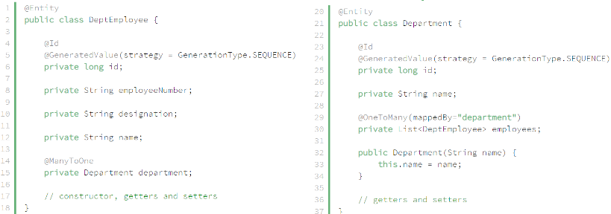

*Entity*

* **Using entity’s constructor**

Get Employee’s name and Department’s name

* + Cách 1: get all property of entity



* + Cách 2: using entity’s constructor



* **Using a Constructor in HQL**

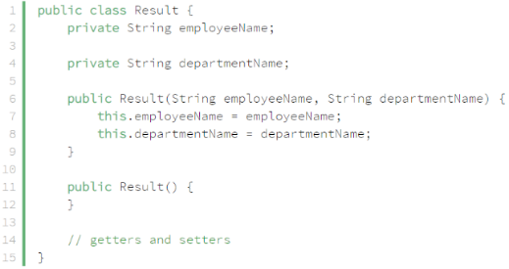

*POJO*

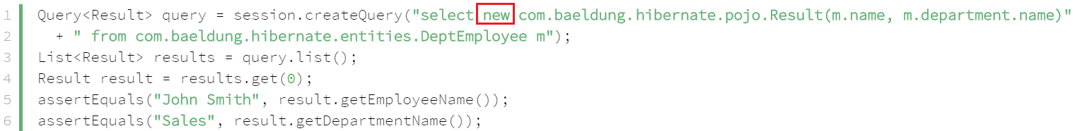

[*https://www.baeldung.com/hibernate-query-to-custom-class*](https://www.baeldung.com/hibernate-query-to-custom-class)

* **Using a ResultTransformer**

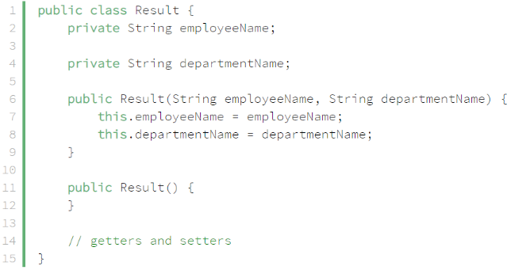

*POJO*

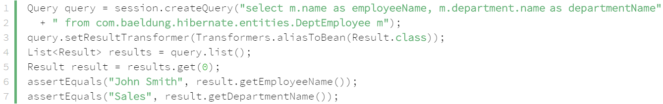

*using the Transformers.aliasToBean() method to use the retrieved data to populate the Result objects*

[*https://www.baeldung.com/hibernate-query-to-custom-class*](https://www.baeldung.com/hibernate-query-to-custom-class)